Eng. Fadi Kreiker
Aulia Rd
Riyadh 11514
Sep 21, 2017

Dear Sir/ Madam,

I am writing to express my interest in applying for vacancies at your organization.

I am currently employed in Saudi Arabia with one of Major regional Real Estate and Investment Company in Riyadh.

I have More than 21 year’s professional experience, working with a reputed companies and Landmark Projects, in different fields. (Contractors, Consultant, Owners)

Highly motivated, Excellent professional experience, High profile and standard technical acknowledgment, Management skills, Risk management, Interpersonal skills, Leadership skills…etc. , Comprehensive knowledge of applicable Forms of Contract, their application and administration, an astute commercial awareness and knowledge of controlling and Consultant organizations, fully conversant with commonly used planning tools and software.

Experiences and skills:
Strong general knowledge.
Strong human capital management knowledge.
Possesses requisite experience in Company structures, Real Estate and operations.
Solid working knowledge of budgeting, business development, and strategic planning.
Ability and passion to generate respect and trust from staff and external constituencies as well as fitting into the senior management team.
Excellent interpersonal, communications, public speaking, and presentation skills.
Detail & process orientated with ability to see the ‘big picture’.
Understanding of financial reporting including budgeting and cash flow management.
Leadership, management and delegation abilities to oversee the company

I believe that the Experiences and skills will be valuable assets for your organization, Attached my CV for your review.

Sincerely,
Dr.Eng. Fadi Kreiker
Riyadh, Saudi Arabia

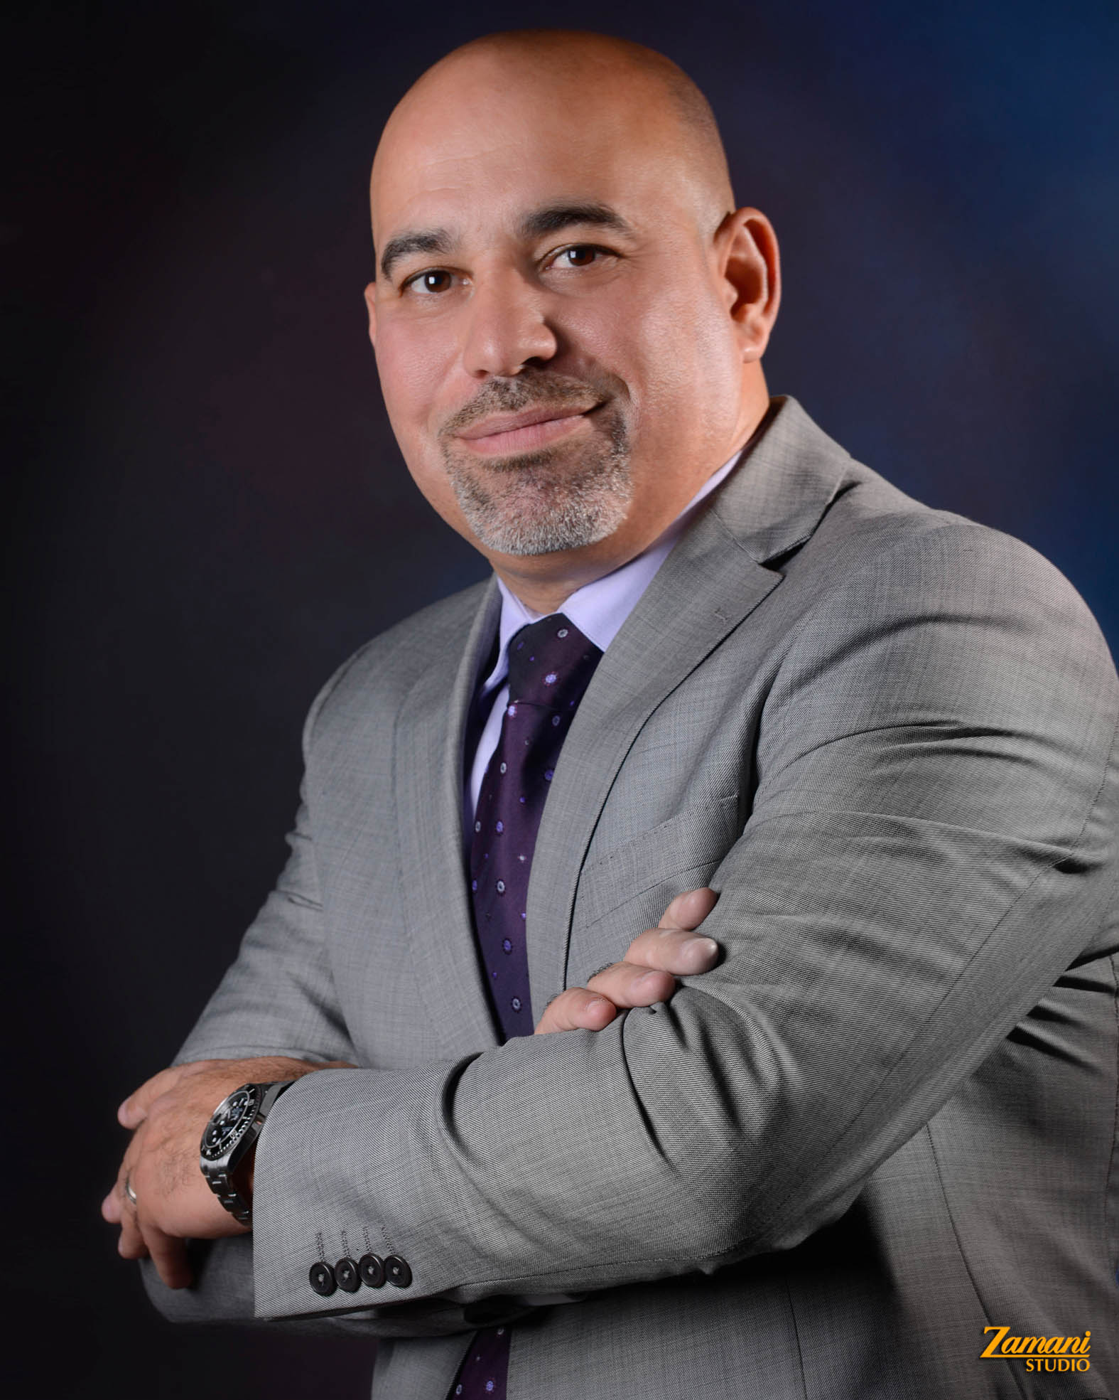

Dr.Eng. FADI KREIKER

Lebanese /Canadian PR

Present Address:

Kingdom of Saudi Arabia

P.O.Box 54485 Riyadh 11514

Email: fkreiker@yahoo.com Mob: +966500955536

Married+ 2 kids address: AL Waha Garden Village Compound – Villa 96

Job Purpose:
Develop the Organization's Mission and Vision
Directing the strategy, growth, and expansion of the company
Support and advise the technical and facility managements divisions
Ensure effective organizational planning
Enhance the organization's public image
Significant improvements in functional design and building services

Specialties
Leadership, General Management, Business Strategy & Business Development, Projects Management, Project Financing, HR Management, Financial & Accounting Research, Leasing Strategy, Procurement, Operations & Facilities Management

Skills
Real Estate, Contract Negotiation, Quality Management, Risk Management,
Team Building, Team, Management, Organizational, Development, Strategic
Planning, Problem
Solving, Government Relations, Logistics.

Career Background

Nov, 2011– till now (K.S.A) (6 Years)  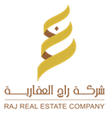

AlRajhi United Investment Holding – Raj Real Estate CO

Projects Director / Head of Engineering Management

Strategic Planning
Lead team to ensure goals are met timely.
Establish strategies for overall corporate entity and individual business.
Develop corporate goals and plans with executive management.
Marketing Strategies and Sales Targets:
Supervise the marketing activities and marketing team in the design and distribution of marketing programs.
Observe and evaluate marketing based on the ongoing sales growth.
Measure the success of marketing and sales programs against defined goals and provide
Budgeting and Expense Control:
Preparing Profit/ Loss reports directly to the owners, in addition to quarterly and annual reports.
Seek the most cost effective and creative ways to reach targets.
Negotiate and manage contracts with clients.

LEBANON, KSA

Sep 01, 2005 – Oct 30, 2011 (6 Years) VP Business Development
Leadership, General Management, Business Strategy & Business Development.
Directing all retail operations and staff, providing leadership to maintain sustainable growth and profitability.
Manage and directs the retail department operations on the basis of profits and ROI.
Research and purchases fixtures for store expansion.
Manage and coordinate year-end inventory and cycle counts.

April 01, 1996 – Aug 01, 2005 (9 Years) Projects Director / Head of Contracts Department
Construction schedules, milestones and monitor progress, agreements, purchase, progress reports, Budgeting and Expense Control.

Association & Organization:
- International Arbitration center. counselor
- Arab Federation for International Arbitration.
- National Society of Professional Engineers in USA. (NSPE )
- U.S Green Building Council.
- Project Management Institute .PMI
- Professional Engineer in Saudi Council Of Engineers
- PMI - Arabian Gulf Chapter (AGC)
- Canadian Council of Professional Engineers.
- Order of Engineers & Architects – Lebanon

EDUCATION:
- Doctorate of Business Administration DBA
- Master of Business Administration MBA
- Master Real Estate Management
- Skills of Successful Manager
- Certified Professional Manager -CPM Certificate
- International Arbitration Diploma, FIDIC – University.
- Green Building Basics & LEED – Saudi Green & U.S Green Building.
- Prince 2 Senior Management Workshop.
- Advanced Project Management Skills.
- Value engineer Analysis– CMCO.
- Project Management Professional – PMI.
- Civil Engineering.

LANGUAGES Arabic & English

INTERESTS & ACTIVITIES
Attending Seminars and Exhibitions Related to the World of Management.
Golf, Squash.

