IN THE NAME OF GOD, THE MERCIFUL, THE COMPASSIONATE

Advocate Dr. Omar Al-Khataibeh

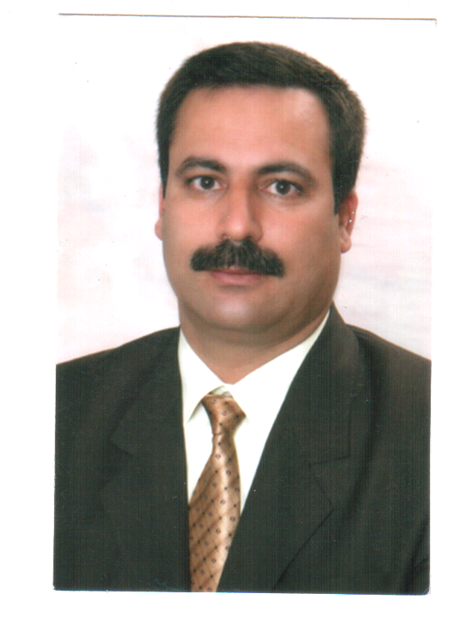
Curriculum Vitae

Name: Omar Mohammad Al-Ibrahim Al-Khataibeh
Place and date of birth: Jordan 10/1/1968
Tel.: 00962795511842
E-mail: okhataibeh@yahoo.com
P.O. Box 1196 Postal Code 11953 Amman
Marital status: married

- Academic qualifications
1- PH.D at General Law, 2010 ) Honor )

2- MA at General Law, Arab Amman Post Graduate University, 2003

3- BA at Law, Jordan University, 1991

- Practical experiences
- A trainee lawyer 1/7/1991-7/7/1993.

- A practicing lawyer since 7/7/1993 till this date (a lawyer licensed to practice before all the courts and the Higher Justice Court).

- International Arbitrator

- Expert of Investment Deputies.

- Expert of bankruptcy.

- A volunteer advisor for Injaz Program (the program offering economic opportunities for the Jordanian youths) since the year 2000.

- A partner with the High UNHCR Commission/Jordan, the Legal Assistance Program till 10/5/2010.

- A legal advisor for the German Vaj Armtron Co. in Jordan.

- A legal advisor for Jordan Veterinary Medicines Manufacturing Co.

- A legal advisor for the Hungarian Airlines (Malive)

- A legal advisor for the National Construction Co.

- A legal advisor for Mohammad Abu Eisheh & Bros Construction Co./Customs Cases.

- An expert and a liquidator appointed by the First Instant Court of Amman for many companies.

- A legal advisor for several other companies and individual establishments.
15- legal advisor of al bahr real estate company.
16- legal advisor of sundos real estate company.
17- legal advisor of Al Jaloody real estate company.
18-legal advisor of Al Rawabdeh real estate company.
19-The proprietor of Justice Law & Training Firm

- Researches and publications
1- The role of the professional associations in posting democracy in Jordan.

2- The investment warranties in the Jordanian Investment Encouragement Law, 1993,.

3- The Easy Way, a specialized economic study that has not been published, 2000.

4- Dissolving the joint company upon the request of any of the partners, 2001.
5-legal system of council in Jordan
5- Writing many stories in the daily newspapers-legal consultations on several issues of the community.

- Community service
First: courses offered by me as an advisor and a lecturer (volunteer) for Injaz Program (the program offering economic opportunities for the Jordanian youths) since the year 2000.

Second: courses offered as a volunteer consultant for Injaz Program at the Jordan University since the first semester 2002/2003 till this date (success skills, leadership, ethics).
1-A member of cairb(charter institute of arbitrator )-uk-london
2-Vice of the training committee president and continues education of
The Jordanian Bar Association.

3- A member at the legal committee at Jordan Environment Protection Society.

4- A member at Cancer Fighting Society.

5- A member at the companies committee at the Bar Association of Jordan.

6- A member at the cultural and laws committees at the Bar Association of Jordan.

7- A member at the committee for developing the curricula of Injaz.

8- A member at the administrative board of Al-Khattab Cooperative Society .

9- A member at the administrative board of Al-Qaduisiyyah Housing Society.

10- A member at the Arab Human Rights Organization.

11- A member at the Jails Committee- Arab Human Rights Organization.

12-Amember at Adallah center for arbitration –cairo.
13-Amember at Arab international arbitrator union.
14-A member of international commercial chamber –Jordan.
15-Member of American international law society.
16-Member at association of Swiss arbitrators.
17-Member at arbitration center of Arab Gulf center.
18-Amember in arbitrators list at authority of water - Jordan
- Courses and conferences

- Inter-Arab investments and the problems of settlement of their disputes (facts, and propose solutions) ", Conference at League of Arab States – Cairo, 10-11 Oct 2011, Cairo-Egypt.

2-Conference and Workshop of arbitration and experts of investment Disputes ,Cairo,Egpt ,23-27 July2011.

3-A course in the field of insurance principles .1/10/2011-25/11/2011.amman -jordan
4- A course in the field of insurance business, Middle East Insurance Co. 20/6/1991-20/7/1991.
5-The role of the judge in arbitration case –international commercial chamber -Amman –Jordan 4-6desember 21011.
6- A course in the field of (Guidance & Legal Assistance Rendering Services 25-27, Queen Zein Al-Sharaf Institute-Amman.

7- A course in the field of the warranties and rights of the lawyer- Queen Zein Al-Sharaf Institute-in cooperation with Mizan Group for human rights 27-29 April, 2000.

8- A workshop on (the right to work on view of the Jordanian Constitution and laws as well as the International conventions), Mizan Group for human rights 5/8/2000.

9- A round table on (the refugees rights on view of the International Law), Mizan Group for human rights 27/5/2000.

10- A course on fighting all the forms of discrimination against the woman (CIDAW), Mizan Group for human rights 9-11/8/2000.

11- A seminar titled the Jordanian Party Experience and the Education on the Necessity to Participate in the Parliament Elections 22/8/1999.

12- The Legal Exchange Conference between the Hashemite Kingdom of Jordan and the United States of America (The Disputes Alternative Solutions Mechanisms) 22-26 July, 1995, the Faculty of Law, University of Jordan.

13- Offering a course on building the institutional capabilities for the volunteering national organizations, 17/8-9/9/2007.

14- A workshop on the e-trade and consumer's rights protection held by the First Instant Court of Amman and the European Community cooperating with the Ministry of Justice, 27-29/7/2010.

15- A training course on (the application of the International conventions on the national level), 20-23/6/2009, Holiday Hotel-Amman delegated by the Head of the Bar Association.

16- A course on promoting the legislative drafting capabilities-29/6-1/7/2009, Kempenski Hotel, Amman, delegated by the Head of the Bar Association.

17- The regional conference on the International Criminal Court-Qatar in cooperation between the International Criminal Court and the Attorney General Department in Qatar and the Arab League, 6-7/10/2010, delegated by the Head of the Bar Association.
18-Many courses at arbitration.
19-the organizer of Amman conference for mediation and arbitration-20-21 june 2012 .
- Skills
1- Computer skills.
2- Good conduct in both Arabic and English.

